T- To know when different trains were invented.

Sort the trains into old and new

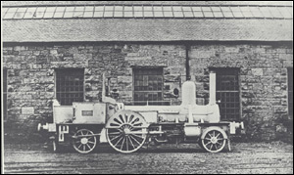[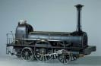](http://images.google.co.uk/imgres?imgurl=http://www.na.infn.it/Museum/schede/jpg/301.jpg&imgrefurl=http://www.na.infn.it/Museum/eng/schede/301.htm&h=394&w=600&sz=33&tbnid=ukfuT9ijgbQOHM:&tbnh=87&tbnw=133&hl=en&start=80&prev=/images%3Fq%3Dstephenson%2Bsteam%26start%3D60%26svnum%3D10%26hl%3Den%26lr%3D%26sa%3DN)[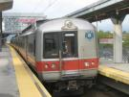](http://images.google.co.uk/imgres?imgurl=http://photos.beckettmw.com/albums/farewellfl9/aae.sized.jpg&imgrefurl=http://photos.beckettmw.com/farewellfl9/aae&h=480&w=640&sz=58&tbnid=YvFqKVY-kFDNtM:&tbnh=101&tbnw=135&hl=en&start=53&prev=/images%3Fq%3Dexpress%2Btrain%26start%3D40%26svnum%3D10%26hl%3Den%26lr%3D%26sa%3DN)

[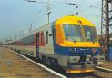](http://images.google.co.uk/imgres?imgurl=http://www.topcardkiado.hu/images/1657.jpg&imgrefurl=http://www.topcardkiado.hu/lista.php%3Fkatalogusid%3Dkat0074%26cim%3DRailway%2520catalogue%25202004.%26nyelv%3Dqen&h=305&w=433&sz=41&tbnid=3KGV9OpksgwSPM:&tbnh=86&tbnw=123&hl=en&start=47&prev=/images%3Fq%3Dinter%2Bcity%2Btrain%26start%3D40%26svnum%3D10%26hl%3Den%26lr%3D%26sa%3DN)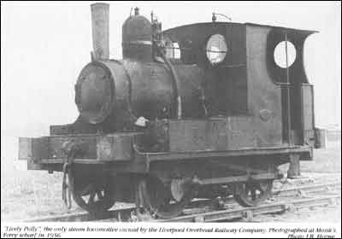[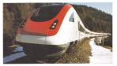](http://images.google.co.uk/imgres?imgurl=http://www.grockland.ch/images/presse/PHOTO%252018A%2520-%2520Train%2520CFF%2520ICN.jpg&imgrefurl=http://www.grockland.ch/f/presse/default.htm&h=547&w=961&sz=87&tbnid=M0NQLnsvMsgpiM:&tbnh=84&tbnw=148&hl=en&start=25&prev=/images%3Fq%3Dtrain%26start%3D20%26svnum%3D10%26hl%3Den%26lr%3D%26sa%3DN)

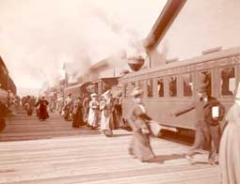

[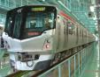](http://images.google.co.uk/imgres?imgurl=http://www.city.tsukuba.ibaraki.jp/hp/e_hp/images/photos/tsukubaexpress.jpg&imgrefurl=http://www.city.tsukuba.ibaraki.jp/hp/e_hp/guide/trains.html&h=250&w=320&sz=23&tbnid=q5CaN96GpFZIdM:&tbnh=88&tbnw=113&hl=en&start=34&prev=/images%3Fq%3Dnew%2Btrains%26start%3D20%26svnum%3D10%26hl%3Den%26lr%3D%26sa%3DN)

[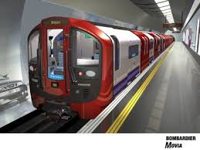](http://images.google.co.uk/imgres?imgurl=http://www.alwaystouchout.com/img/projects/victrain400.jpg&imgrefurl=http://www.alwaystouchout.com/project/40&h=300&w=400&sz=22&tbnid=Hz0RfPNoJYHbqM:&tbnh=90&tbnw=120&hl=en&start=60&prev=/images%3Fq%3Dnew%2Btrains%26start%3D40%26svnum%3D10%26hl%3Den%26lr%3D%26sa%3DN)

Old New

2.  Write some sentences about which trains are old and new.  Think about how you know this?